CSCI 585 HW3 Report

Name:HAO WU

USC ID:1699530173

Email: hwu638@usc.edu

For this assignment, I choose 11 places to point in the map. Except for the 5 places are required, I choose Massman Theartre, Olin Hall, Bovard Auditorium, Leavey Library, Doheny Memorial and Capone Lab as other places to analyse. The reason I choose them is that parts of them are all the place I usually go to and the rest of them are the place I am curious for. Olin Hall is the place I had my classes. Bovard Auditorium, Leavey and Doheny library are also familiar to me. I’ve heard of massman theartre and capone lab from my friends.

**KML FILE FOR 5A**

<?xml version="1.0" encoding="UTF-8"?>

<kml xmlns="http://earth.google.com/kml/2.0">

<Document>

<Style id="s">

<IconStyle><Icon><href>http://www.google.com/intl/en_us/mapfiles/ms/micons/blue-dot.png</href></Icon></IconStyle>

</Style>

<Placemark><name>My Home</name>

<styleUrl>#s</styleUrl><Point><coordinates>-118.290372,34.027550</coordinates></Point>

</Placemark>

<Placemark><name>Vermont/Jefferson</name>

<styleUrl>#s</styleUrl><Point><coordinates>-118.291613,34.025473</coordinates></Point>

</Placemark>

<Placemark><name>Exposition/Vermont</name>

<styleUrl>#s</styleUrl><Point><coordinates>-118.291526,34.018355</coordinates></Point>

</Placemark>

<Placemark><name>Jefferson/Figueroa</name>

<styleUrl>#s</styleUrl><Point><coordinates>-118.280027,34.022035</coordinates></Point>

</Placemark>

<Placemark><name>Figueroa/Exposition</name>

<styleUrl>#s</styleUrl><Point><coordinates>-118.282316,34.018428</coordinates></Point>

</Placemark>

<Placemark><name>Olin Hall</name>

<styleUrl>#s</styleUrl><Point><coordinates>-118.289694,34.020625</coordinates></Point>

</Placemark>

<Placemark><name>Massman Theartre</name>

<styleUrl>#s</styleUrl><Point><coordinates>-118.289975,34.022699</coordinates></Point>

</Placemark>

<Placemark><name>Bovard Auditorium</name>

<styleUrl>#s</styleUrl><Point><coordinates>-118.285538,34.020923</coordinates></Point>

</Placemark>

<Placemark><name>Leavey Library</name>

<styleUrl>#s</styleUrl><Point><coordinates>-118.282819,34.021796</coordinates></Point>

</Placemark>

<Placemark><name>Doheny Memorial</name>

<styleUrl>#s</styleUrl><Point><coordinates>-118.283755,34.020138</coordinates></Point>

</Placemark>

<Placemark><name>Capone Lab</name>

<styleUrl>#s</styleUrl><Point><coordinates>-118.284976,34.019706</coordinates></Point>

</Placemark>

<Style id="transBluePoly">

<LineStyle>

<width>1.5</width>

</LineStyle>

<PolyStyle>

<color>7dff0000</color>

</PolyStyle>

</Style>

<Placemark>

<name>Convex Hull</name>

<visibility>1</visibility>

<styleUrl>#transBluePoly</styleUrl>

<Polygon>

<extrude>1</extrude>

<altitudeMode>relativeToGround</altitudeMode>

<outerBoundaryIs>

<LinearRing>

<coordinates> -118.291526,34.018355,17

-118.291613,34.025473,17

-118.290372,34.02755,17

-118.280027,34.022035,17

-118.282316,34.018428,17

-118.291526,34.018355,17</coordinates>

</LinearRing>

</outerBoundaryIs>

</Polygon>

</Placemark>

</Document>

</kml>

**KML FILE FOR 5B**

<?xml version="1.0" encoding="UTF-8"?>

<kml xmlns="http://earth.google.com/kml/2.0">

<Document>

<Style id="s">

<IconStyle><Icon><href>http://www.google.com/intl/en_us/mapfiles/ms/micons/blue-dot.png</href></Icon></IconStyle>

</Style>

<Placemark><name>My Home</name>

<styleUrl>#s</styleUrl><Point><coordinates>-118.290372,34.027550</coordinates></Point>

</Placemark>

<Placemark><name>Vermont/Jefferson</name>

<styleUrl>#s</styleUrl><Point><coordinates>-118.291613,34.025473</coordinates></Point>

</Placemark>

<Placemark><name>Exposition/Vermont</name>

<styleUrl>#s</styleUrl><Point><coordinates>-118.291526,34.018355</coordinates></Point>

</Placemark>

<Placemark><name>Jefferson/Figueroa</name>

<styleUrl>#s</styleUrl><Point><coordinates>-118.280027,34.022035</coordinates></Point>

</Placemark>

<Placemark><name>Figueroa/Exposition</name>

<styleUrl>#s</styleUrl><Point><coordinates>-118.282316,34.018428</coordinates></Point>

</Placemark>

<Placemark><name>Olin Hall</name>

<styleUrl>#s</styleUrl><Point><coordinates>-118.289694,34.020625</coordinates></Point>

</Placemark>

<Placemark><name>Massman Theartre</name>

<styleUrl>#s</styleUrl><Point><coordinates>-118.289975,34.022699</coordinates></Point>

</Placemark>

<Placemark><name>Bovard Auditorium</name>

<styleUrl>#s</styleUrl><Point><coordinates>-118.285538,34.020923</coordinates></Point>

</Placemark>

<Placemark><name>Leavey Library</name>

<styleUrl>#s</styleUrl><Point><coordinates>-118.282819,34.021796</coordinates></Point>

</Placemark>

<Placemark><name>Doheny Memorial</name>

<styleUrl>#s</styleUrl><Point><coordinates>-118.283755,34.020138</coordinates></Point>

</Placemark>

<Placemark><name>Capone Lab</name>

<styleUrl>#s</styleUrl><Point><coordinates>-118.284976,34.019706</coordinates></Point>

</Placemark>

<Style id="transBluePoly">

<LineStyle>

<width>1.5</width>

</LineStyle>

<PolyStyle>

<color>7dff0000</color>

</PolyStyle>

</Style>

<Placemark>

<name>Convex Hull</name>

<visibility>1</visibility>

<styleUrl>#transBluePoly</styleUrl>

<Polygon>

<extrude>1</extrude>

<altitudeMode>relativeToGround</altitudeMode>

<outerBoundaryIs>

<LinearRing>

<coordinates> -118.291526,34.018355,17

-118.291613,34.025473,17

-118.290372,34.02755,17

-118.282819,34.021796,17

-118.283755,34.020138,17

-118.284976,34.019706,17

-118.291526,34.018355,17

</coordinates>

</LinearRing>

</outerBoundaryIs>

</Polygon>

</Placemark>

</Document>

</kml>

<?xml version="1.0" encoding="UTF-8"?>

<kml xmlns="http://earth.google.com/kml/2.0">

<Document>

<Style id="s">

<IconStyle><Icon><href>http://www.google.com/intl/en_us/mapfiles/ms/micons/blue-dot.png</href></Icon></IconStyle>

</Style>

<Placemark><name>My Home</name>

<styleUrl>#s</styleUrl><Point><coordinates>-118.290372,34.027550</coordinates></Point>

</Placemark>

<Placemark><name>Vermont/Jefferson</name>

<styleUrl>#s</styleUrl><Point><coordinates>-118.291613,34.025473</coordinates></Point>

</Placemark>

<Placemark><name>Exposition/Vermont</name>

<styleUrl>#s</styleUrl><Point><coordinates>-118.291526,34.018355</coordinates></Point>

</Placemark>

<Placemark><name>Jefferson/Figueroa</name>

<styleUrl>#s</styleUrl><Point><coordinates>-118.280027,34.022035</coordinates></Point>

</Placemark>

<Placemark><name>Figueroa/Exposition</name>

<styleUrl>#s</styleUrl><Point><coordinates>-118.282316,34.018428</coordinates></Point>

</Placemark>

<Placemark><name>Olin Hall</name>

<styleUrl>#s</styleUrl><Point><coordinates>-118.289694,34.020625</coordinates></Point>

</Placemark>

<Placemark><name>Massman Theartre</name>

<styleUrl>#s</styleUrl><Point><coordinates>-118.289975,34.022699</coordinates></Point>

</Placemark>

<Placemark><name>Bovard Auditorium</name>

<styleUrl>#s</styleUrl><Point><coordinates>-118.285538,34.020923</coordinates></Point>

</Placemark>

<Placemark><name>Leavey Library</name>

<styleUrl>#s</styleUrl><Point><coordinates>-118.282819,34.021796</coordinates></Point>

</Placemark>

<Placemark><name>Doheny Memorial</name>

<styleUrl>#s</styleUrl><Point><coordinates>-118.283755,34.020138</coordinates></Point>

</Placemark>

<Placemark><name>Capone Lab</name>

<styleUrl>#s</styleUrl><Point><coordinates>-118.284976,34.019706</coordinates></Point>

</Placemark>

<Style id="transBluePoly">

<LineStyle>

<width>1.5</width>

</LineStyle>

<PolyStyle>

<color>7dff0000</color>

</PolyStyle>

</Style>

<Placemark>

<name>Convex Hull</name>

<visibility>1</visibility>

<styleUrl>#transBluePoly</styleUrl>

<Polygon>

<extrude>1</extrude>

<altitudeMode>relativeToGround</altitudeMode>

<outerBoundaryIs>

<LinearRing>

<coordinates> -118.282316,34.018428,17

-118.289694,34.020625,17

-118.289975,34.022699,17

-118.280027,34.022035,17

-118.282316,34.018428,17

</coordinates>

</LinearRing>

</outerBoundaryIs>

</Polygon>

</Placemark>

</Document>

</kml>

**Table creation Command：**

create table spatialDB(

ID Integer not null,

Name varchar(50) not null,

Point geometry not null,

Primary key(ID));

insert into spatialDB values

(1,'My Home',ST_MakePoint(-118.290372,34.027550)),

(2,'Vermont/Jefferson',ST_MakePoint(-118.291613,34.025473)),

(3,'Exposition/Vermont',ST_MakePoint(-118.291526,34.018355)),

(4,'Jefferson/Figueroa',ST_MakePoint(-118.280027,34.022035)),

(5,'Figueroa/Exposition',ST_MakePoint(-118.282316,34.018428)),

(6,'Olin Hall',ST_MakePoint(-118.289694,34.020625)),

(7,'Massman Theartre',ST_MakePoint(-118.289975,34.022699)),

(8,'Bovard Auditorium',ST_MakePoint(-118.285538,34.020923)),

(9,'Leavey Library',ST_MakePoint(-118.282819,34.021796)),

(10,'Doheny Memorial',ST_MakePoint(-118.283755,34.020138)),

(11,'Capone Lab',ST_MakePoint(-118.284976,34.019706));

**Query for question a:**

select ST_AsText(ST_ConvexHull

(ST_Collect(Point))) from spatialDB;

result: POLYGON((-118.291526 34.018355,-118.291613 34.025473,-118.290372 34.02755,-118.280027 34.022035,-118.282316 34.018428,-118.291526 34.018355))

**Query for question b:**

SELECT ST_Disjoint(

(

select ST_AsText(ST_ConvexHull

(ST_Collect(Point))) from spatialDB where ID BETWEEN 1 AND 3 OR ID BETWEEN 9 AND 11

),

(

select ST_AsText(ST_ConvexHull

(ST_Collect(Point))) from spatialDB where ID BETWEEN 4 AND 8

)

);

result:

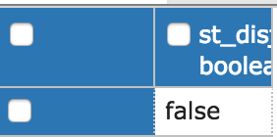

**Screen shot for question 5：**

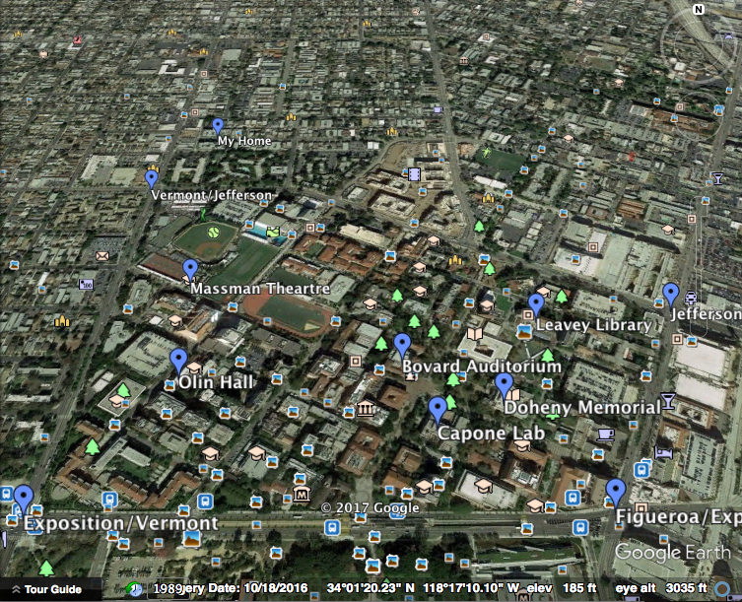

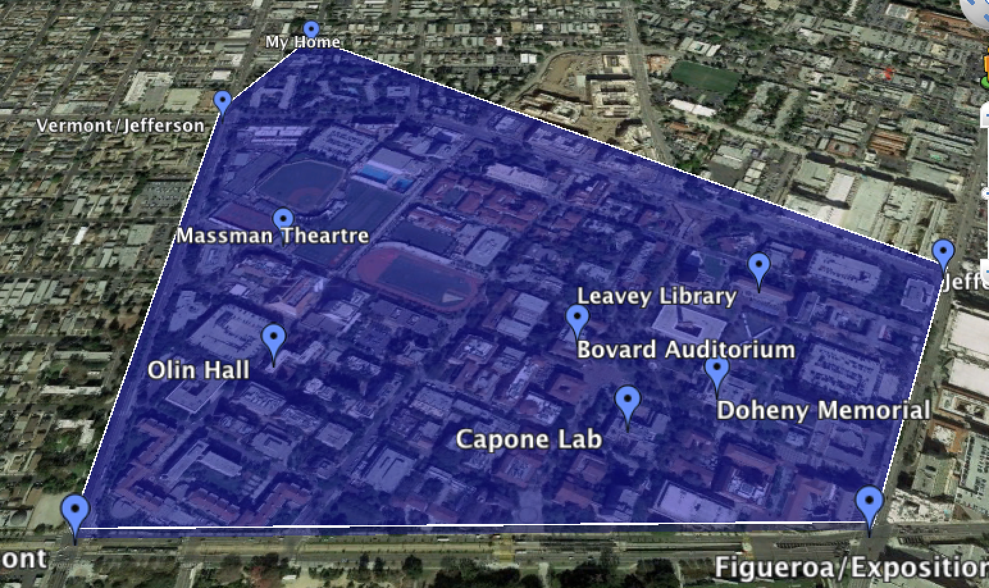

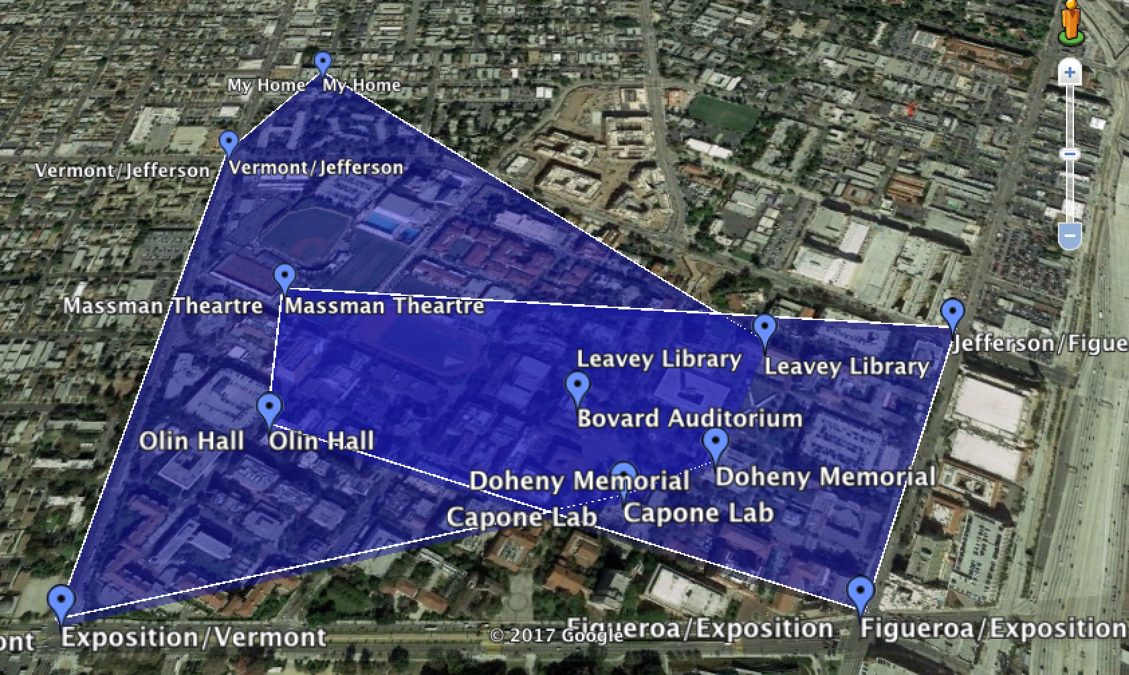

|  |  |  |
| --- | --- | --- |
| **Issue id** | **Issue description** | **Issue solution** |
| **1** | **Can’t connect AWS from Local. PgAdmin4 shows error when connecting to AWS.** | **Reset the port.** |
| **2** | **Can’t use postGIS.** | **Execute the sql sentence: create extension postgis** |
| **3** | **Can’t draw the proper graph for convex hull.** | **Add** **altitude value to every coordinate.** |